Project Management Report from Belo Horizonte

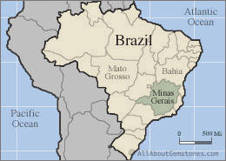

By Manuel Carvalho da Silva Neto
International Correspondent
Minas Gerais, Brazil

OH, GOD! AGAIN!

Brazil is recovering from a deep economic recession period. Despite a slight NGP increase in 2018 (around 1%), we still have 12 million people unemployed, plus other 4,7 million discouraged or despondent (people who gave up finding a new job).

A new government had been elected last October. A right-wing wave swept leftists and a lot of traditional and conservative politicians. People appealed for new names and new options.

Jair Bolsonaro, a retired Army Captain, politician since 1988, was elected president. His winner campaign had used almost just social medias. In September, he was stabbed in a campaign event. This stabbing probably helped his election. Problem: he has no executive experience and is quite radical, at least in his speeches. But he is depositary of huge hopes. Consider if he fails to achieve these hopes? He’s acting since January 1st.

Minas Gerais elected as governor, a young medium size family company owner. Romeu Zema has been elected against polls, old politicians, unions, leftists and the late governor who was trying reelection.

Minas Gerais is a broken state. Its deficit is something like R$ 11 billion (US$ 3 billion) in a budget who previews a R$ 100 billion (US$ 25 billion) incomes. State civil servants receive their salaries in 2 or 3 installments, each month. According to Constitution and legal framework, states should pass to municipalities (counties) part of their incomes. Minas Gerais has a debt with its 853 municipalities around R$ 4,7 billion (US$ 1,3 billion). Vice-Governor confessed that Minas lives a Sofia Dilemma, or pays civil servants and some suppliers, or pays municipalities.

Minas Gerais has an important portion of its incomings from mining companies. VALE is the most important of these mining companies acting in Minas, where she produces almost 50% of its iron ore and has more than 25.000 employees. So, VALE is a huge Minas Gerais economic force. But …

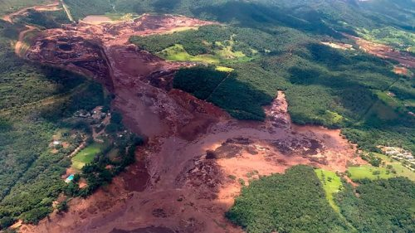
Last January 25, another VALE mine dam collapsed in Minas Gerais. This time, a deadly collapse. Till now (March 18) 206 people were confirmed died and another 102 were not found yet. This is equivalent to 308 lives lost. A huge accident.

A lot of people think that this wasn´t an accident, but a crime, caused by neglect and greed. (photo showing range of mud and environmental damage, courtesy of Mole.com)

The problem is that VALE certified that dam as stable, just a few days before the tragedy. Guess if it were unstable.

Remember that 3 years ago a SAMARCO (company owned by VALE and BHP) dam collapsed causing 19 deaths and a very serious environment damage. This time deaths were much larger, but environmental impact should be smaller.

In consequence, a lot of VALE´s other mines in Minas Gerais were shut down. As the state economy and jobs depend significantly on this mining activities, the things are coming worse.

No activity, no taxes and jobs threatened.

At least some companies who operate in Minas Gerais are helping. GERDAU, a steel company, announced a R$ 1.6 billion (US$ 420 million) investment in its Ouro Branco facilities. USIMINAS, another steel company, will revamp one of its blast furnaces spending R$ 1 billion (US$ 270 million). Both companies have their own engineering team. But these are projects.

FIAT CHRYSLER is investing R$ 8 billion (US$ 2,37 billion) in one of its factories in Minas Gerais. As we know, car producers create an important multiplier effect.

Problems, but some hope!

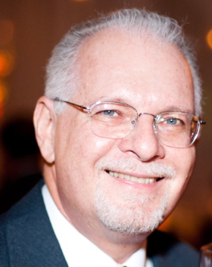
About the Author

Manuel Carvalho da Silva Neto

Minas Gerais, Brazil

Manuel Carvalho da Silva Neto, MSc, Mech. Engineer and PMP is Fundação Dom Cabral Invited Professor and also Consultant. He is a seasoned professional with over 44 years of experience in Project Management, Process Management and Strategy. Manuel has managed or participated in more than four hundred huge projects across different fields including Steel, Mining, IT, Telecom, Food Processing, Government and Construction, to mention a few. He worked also in projects to implement PMO (Project Management Office) and Project Management Methodology. He has also strong skills in Leading People and Finance. He served as Minas Gerais State Undersecretary for Planning and Budget, from 2007 to 2008. Manuel can be contacted at carvalhoneto.manuel@gmail.com.

